Facing the Challenges of Our Times

Technology’s Role in Human Evolution

Transforming Elementals

Developing a Hygienic Occultism

*All in the Light of Anthroposophy*

# *With Are Thoresen, Andrew Linnell, & Theodor Hundhammer*

# A series of study intensives offered by [MysTech](https://www.mystech.org)

**Throughout Rudolf Steiner's years of lecturing, he warned about the dangers as well as the necessary role of technology in our evolution. In his last Letters to Members, he explained how evolution has brought us to a mastery of the physical, of Nature, and how technology will pull us down into the realm of sub-nature. This is unavoidable and throughout his lectures where he discussed the dangers of technology, Steiner offered us counterbalances. We'll explore these and how to balance our exposure to sub-nature by consciously entering the realms of super-nature (the etheric and astral realms). Eurythmy, a movement artform first developed by Rudolf Steiner, will be shown to be an important counterbalancing activity. How to bring Christ into our work in the transformation of technology's elementals.**

**There are certain tasks to be fulfilled by the peoples of specific geographic regions of the Earth. Steiner described some of these tasks in lecture 3 of *The Challenge of the Times* where he discussed three distinct streams of occultism: Eugenic in the East, Hygienic in the Middle, and Mechanical in the West and in North America in particular. He indicated that America has a defined role for the 7th Post-Atlantean Cultural Age for which our technological developments play a key preparatory role. MysTech’s purpose is to help realize this Mechanical Occultism in the West. The Middle has inherent skills to find the Hygienic, the counterbalances and ways to heal such as offered by Eurythmy. It is therefore essential for Eurythmy Therapists to recognize the polarity of Eurythmy to technology and to consciously work with it to counterbalance our descent into the sub-nature upon the back of technology. The Eugenic Occultism apparently has yet to commence.**

**You are invited to participate in this series of lectures and workshops where we will explore technology from a spiritual scientific perspective. We will discuss the role of elementals, Vulcans, and adversarial beings that shape human evolution. We will engage in Eurythmy Therapeutic work that can help counterbalance the adverse effects of technology. We will offer other exercises and practices that can help you understand, manage, and transform your relationship to technology and to modern life. We hope that by the end of our work together, you will feel better resourced to understand the role of technology in human evolution and thereby to contribute to the future for the good of humanity and the world.**

**MysTech is a not-for-profit Anthroposophical organization devoted to cultivating a relationship between Mankind and machine that will be healthy and helpful for future evolution. MysTech hopes to attain ‘critical mass’ whereby it can support research and development. Towards this goal, MysTech offers numerous study groups, webinars, and an annual conference.**

#### A person in a striped shirt Description automatically generatedAndrew Linnell

Andrew Linnell is co-founder of [MysTech](https://mystech.org/), an Anthroposophical organization seeking to realize Rudolf Steiner's indications on Mechanical Occultism. In 1978-79, he took the Foundation Year at Emerson College, Sussex, UK. He has served as president of the Boston branch of the Anthroposophical Society and as admin to several Anthroposophical Facebook groups. He is an active member of the Natural Science Section and its steering committee. In 2013, he retired from a 42-year career in the computer industry where he had served as CTO or VP for small companies. He is the author of three art history books, two children’s books, and seven study guidebooks that explore the role of technology in human evolution.

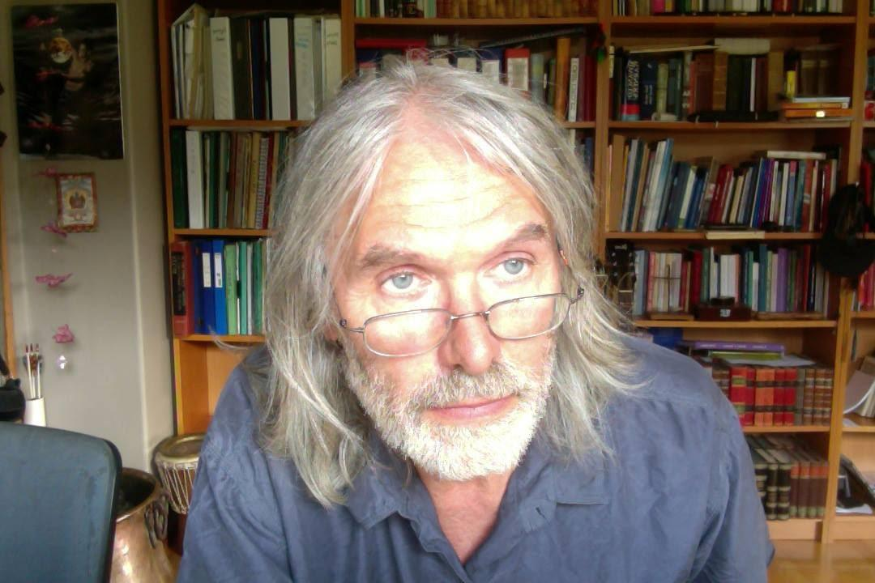**Are Thoresen**

Are Thoresen, MVD, has trained in acupuncture, homeopathy, and anthroposophical medicine and operates a holistic private veterinary practice in Sandefjord, Norway. He has been active with MysTech since its first conference with his focus on Hygienic Occultism. He has published over 25 papers and 10 books and given lectures and workshops about his research at various venues including these MysTech conferences. Are’s current research has focused on Vidar and the Northern Way of Initiation. In his written works, Are has explored the human potential for spiritual knowledge and for new spiritual experiences in our time. He will share exercises to go beyond the veils of the sense world to experience the three realms of elementals.

**Theodor Hundhammer**

Theodor Hundhammer is the founder of [Eurythmy4you](https://www.eurythmy4you-en.com/). He produces the videos and is responsible for the content. He has a eurythmy therapy practice in Bern and in Biel in Switzerland. You can book individual sessions with him, or invite him to teach a class near you. After completing his degree, he worked for four years as a plant engineer at WALA-Heilmittel GmbH, during which time he dealt with the spiritual significance of technology for humans. Theodor practices in Bern and Biel in Switzerland. In addition to his therapeutic work, he worked at FAIRMED until 2011 as a project administrator for health projects in Africa and Asia. From 2011 to 2020 Theodor was board member and president of the Eurythmy Therapy Professional Association Switzerland.

# Event Schedule

**Friday 15 March 2024**

19:30 – 20:15 Lecture 1 Facing Elementals, Fear, and the Challenges of Our Times (AT)  
20:15 – 21:00 Lecture 2 AI and the Incarnation of Ahriman (AL)  
21:00 – 21:30 Discussion (AL, AT, TH and local moderator)

**Saturday 16 March 2024**

09:30 – 09:50 Coffee and Social

09:50 – 10:00 Welcome and introductions

10:00 – 10:45 Lecture Dealing with Evil, Electricity, and Evolution. (AL)   
10:45 – 11:30 Eurythmy as Counterbalance 1 (TH)  
11:30 – 11:45 Coffee and refreshments  
11:45 – 12:45 Entering the Etheric on the Northern Path 1 (AT)  
12:45 – 13:45 Lunch break  
13:45 – 14:45 Entering the Etheric on the Northern Path 2 (AT)  
14:45 – 15:45 Eurythmy as Counterbalance 2 (TH)  
15:45 – 16:15 Refreshments  
16:15 – 17:15 Open Forum Discussion (AL, AT, TH and local person as moderator)

17:15 – 19:00 Dinner Break

19:00 – 19:30 Social time

19:30 – 21:00 Lecture with Q&A (AL) The Cosmic Purpose for AI and Transhumanism.

**Sunday 17 March 2024**

09:30 – 09:50 Coffee and Social

09:50 – 10:00 Welcome and questions (local moderator)

10:00 – 11:00 Lecture Mechanical Occultism, Morality, and the Christ Within (AL)  
11:00 – 11:15 Coffee and refreshments  
11:15 – 12:00 Eurythmy as Counterbalance 3 (TH)

12:00 – 13:00 Q&A and Conversation (AL, AT, TH and local moderator)  
13:00 – 13:45 Lunch break

13:45 – 14:30 Forum (AL + AT + local)

14:30 – 15:30 Vidar and the New Mysteries (AT)

15:30 – 15:45 **Closing** (local moderator)

# Registration and Suggested Donations

**https://www.ticketsource.co.uk/rudolf-steiner-house/t-ojqdyvp**, March 15-17