**T H E P R E S E N T**

**P A R E N T P R A C T I C E**

**R E S T O R I N G C O N N E C T I O N A N D P R E S E N C E - F O R C H I L D R E N , F A M I L I E S , A N D T H E C O M M U N I T I E S A R O U N D T H E M**

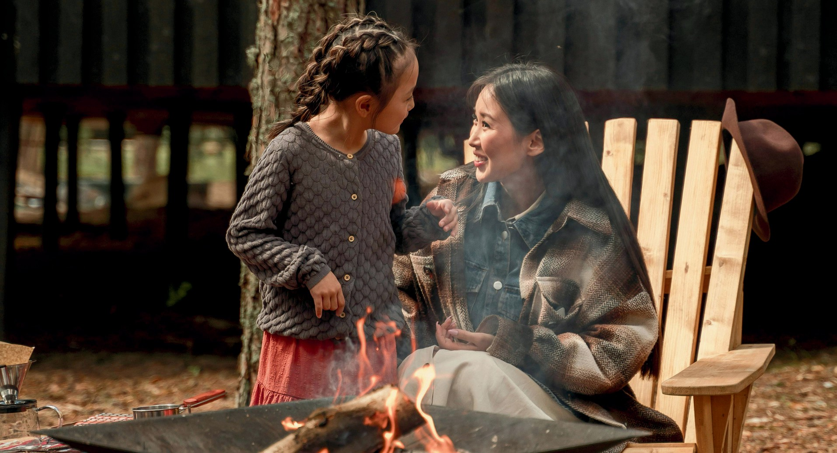

**A 6-Month Journey to Transform Your Parenting from the Inside Out**

## Practical tools and gentle practices help you return to what matters most: a home where everyone feels safe and seen.

Facilitator: Julie Lam - Author of *From the Heart of Childhood*, School Founder, Course Leader, and Transformative Guide

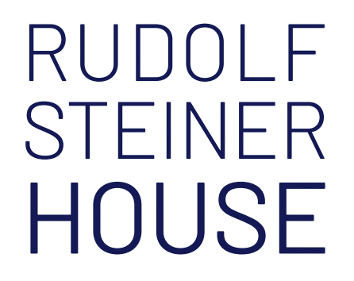**Monthly Saturdays, 2:30 - 4:30 pm**

at Rudolf Steiner House, London, NW1 6XT

+ Online Support

## [www.julie-lam.com](http://www.julie-lam.com/)

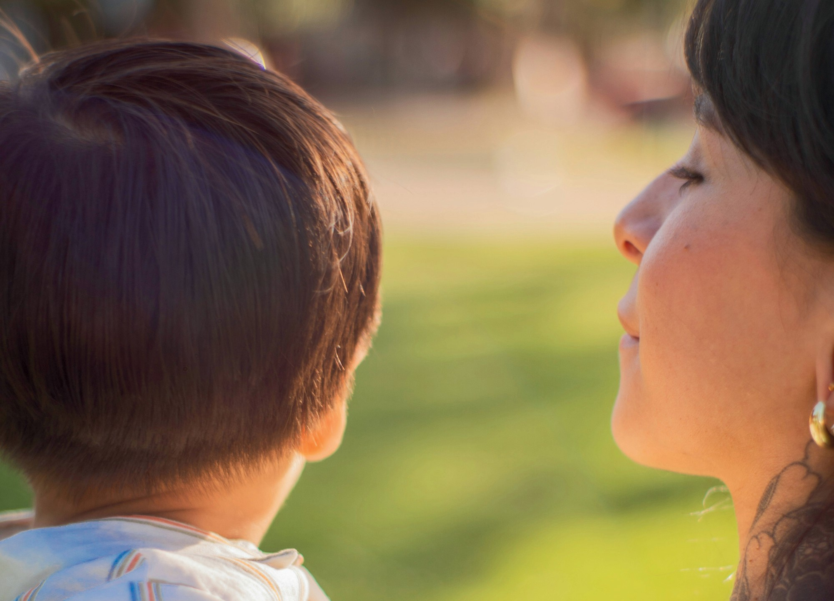

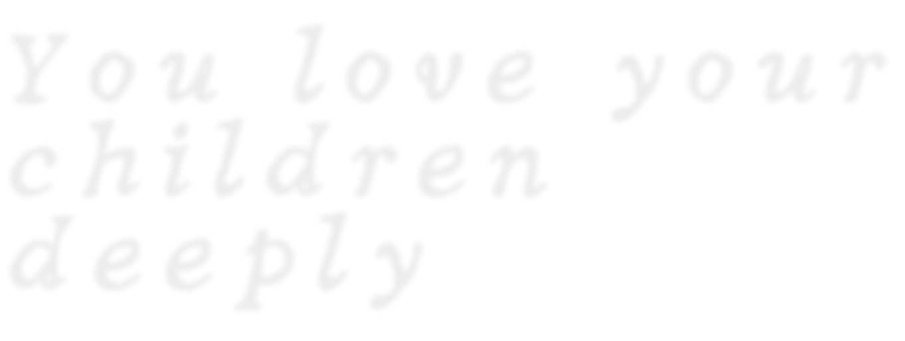

*Y o u l o v e y o u r*

*c h i l d r e n*

*d e e p l y*

— but sometimes the power struggles, the repetition of old family patterns, and the overwhelm of daily life pull you away from the parent you want to be.

This course isn’t about learning a new set of tips or tricks. It’s about becoming the **calm, connected, present** parent your children need — by healing the childhood wounds and unconscious patterns that shape your reactions.

*T h e J o u r n e y*

**

**Monthly in-person gatherings** to explore each developmental stage, supported by conversations to activate new ways of relating and deep personal healing.

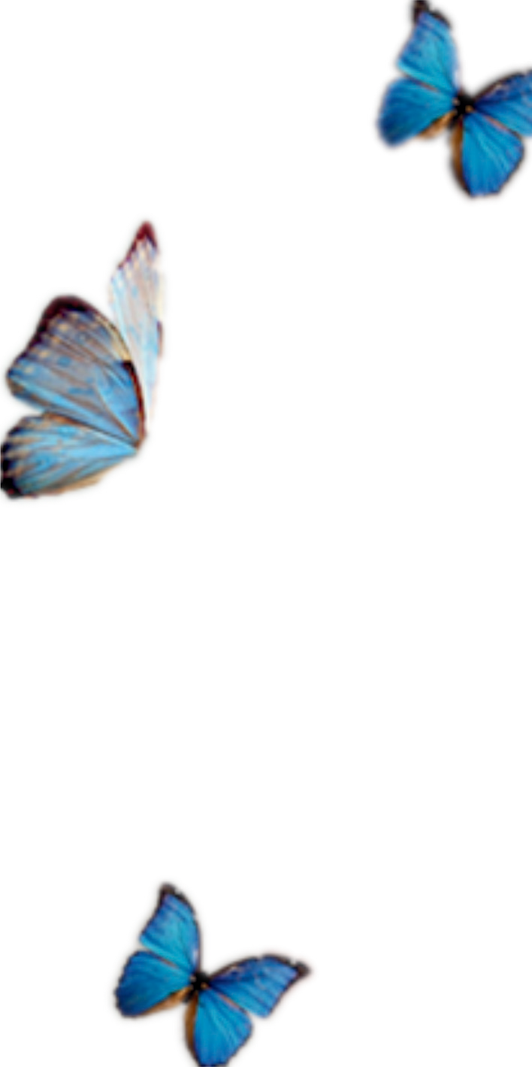**Bi-weekly online support sessions** to integrate what you’re learning into daily life.

**Ongoing connection** through a private community, listening partnerships, and guided resources.

*E a c h m o n th b u i l d s o n*

*th e l a s t*

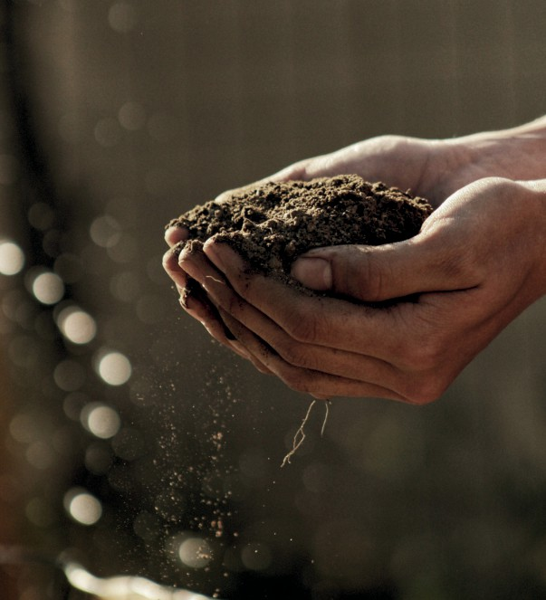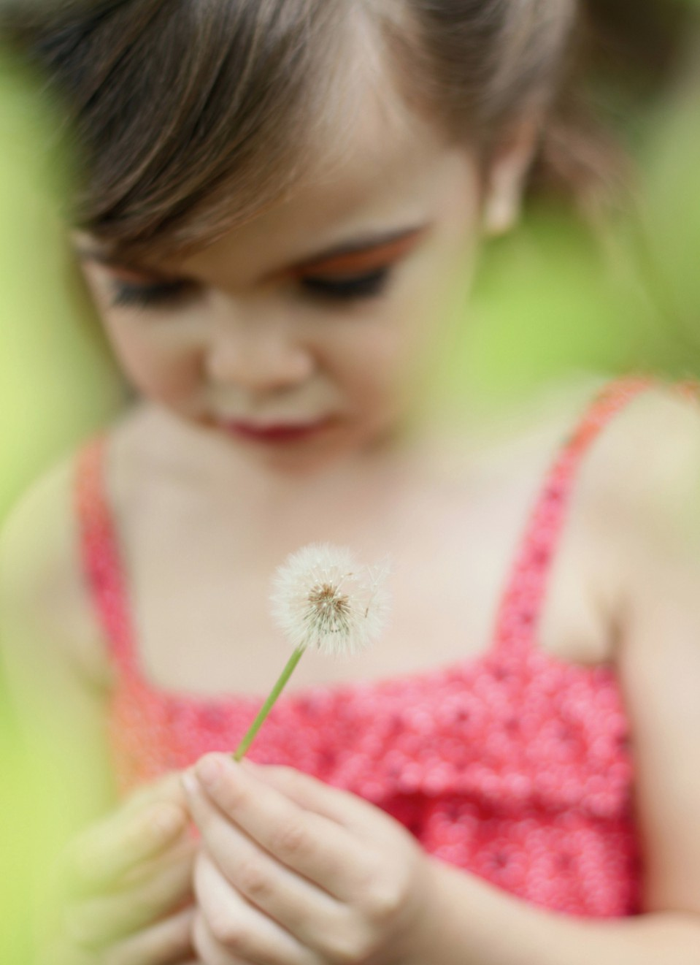

From creating emotional safety, to understanding your child’s inner world, to mastering your role in each developmental phase, and finally weaving it all together into a sustainable way of living and parenting.

*B y th e e n d , y o u w i l l*

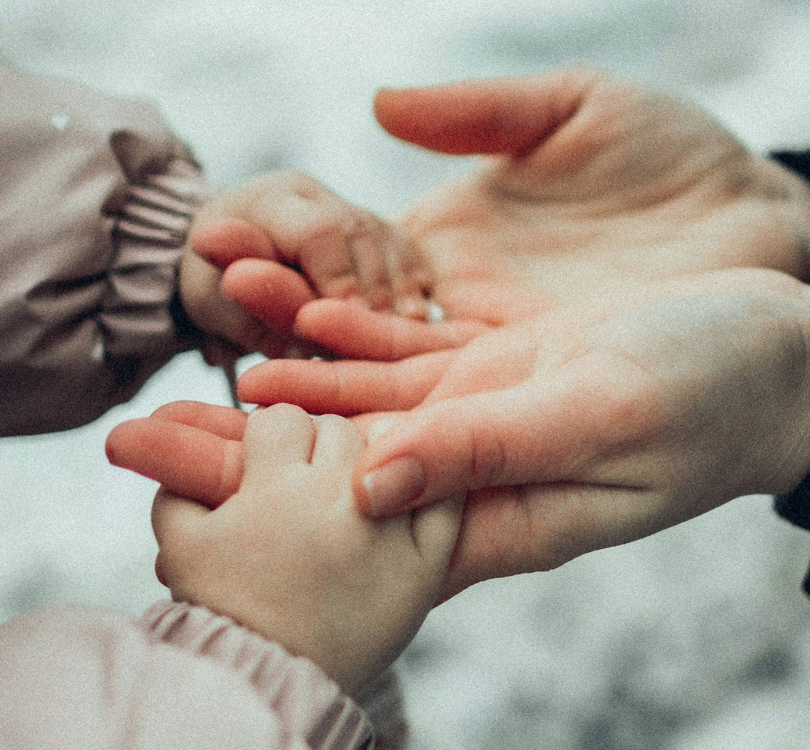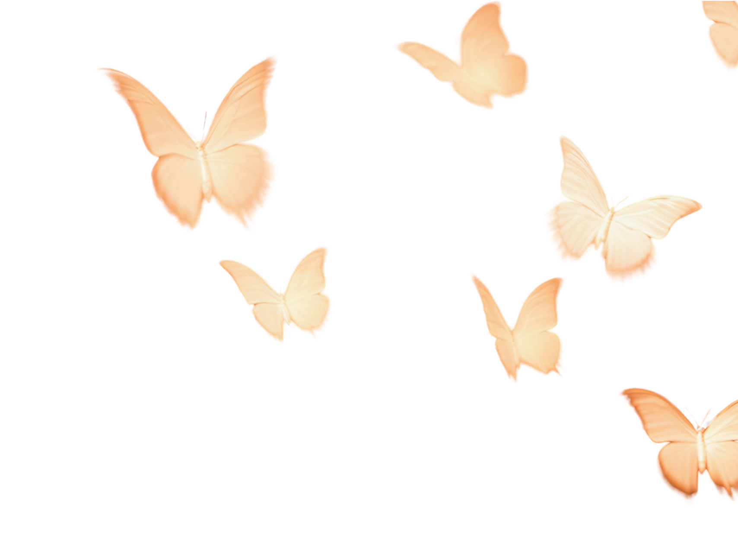

Respond to your children with calm rather than reactivity. Understand their needs beneath the behaviour, even in moments of conflict.

Create a home atmosphere that feels lighter, warmer, and more harmonious.

Model healthy communication and emotional regulation.

See your children flourish in the safety of your steady presence.

**T H E P R E S E N T**

**P A R E N T P R A C T I C E**

**C O U R S E D E T A I L S**

# Dates

Saturdays 2:30 - 4:30 pm Rudolf Steiner House London NW1 6XT

22 November

24 January

21 February

21 March

18 April

16 May

# Cost

November (taster): 1 in-person + 1 online - £50 January - May: 5 in-person + 5 online - £300

*Proceeds from the course go directly to Highgate House School, a Steiner Waldorf Nursery and Kindergarten in Hong Kong.*

**H O W T O B O O K**

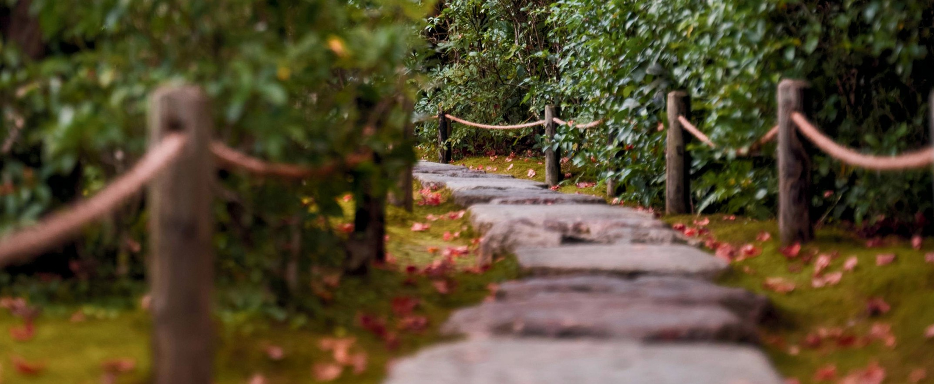1 Book a Discovery Call with Julie: [julie.a.lam@gmail.com](mailto:julie.a.lam@gmail.com)

1. Attend a free Online Session and Q&A on Friday 17 October 1:00- 2:00pm (details provided by Julie)
2. Reserve your place on the November taster with Julie.
3. Sign up for the full course



**A B O U T T H E F A C I L I T A T O R**

**Julie** is the author of *From the Heart of Childhood: Reclaiming Presence for Connection* and the creator of *The Present Parent Practice*. A mother and grandmother, she draws on more than 35 years of experience as an education consultant and guide. Trained in Waldorf and Montessori education, Pikler’s respectful care approach, and therapeutic play, Julie brings together a rare depth of understanding of childhood and family life. As founder of *Highgate House Steiner Waldorf Kindergarte*n in Hong Kong, she nurtured a community where presence and relationship could truly flourish. Her lifelong work continues as a transformative guide, course creator, and leader of groups, where parents and educators access the healing treasures that arise when we come together. Rooted in authenticity and depth, Julie’s approach invites us to care for children—and our own inner child—through the art of connected presence.

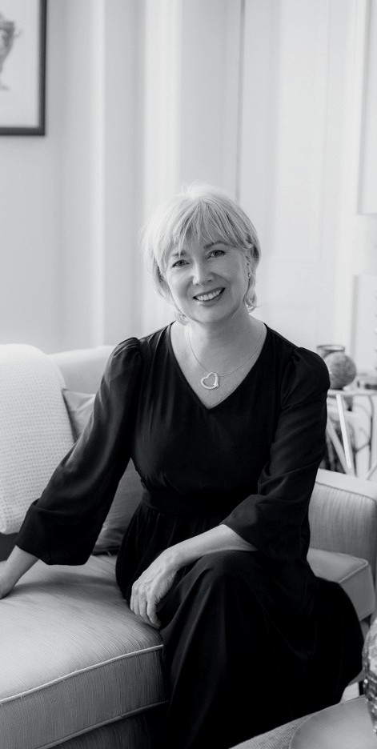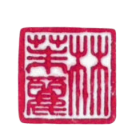

*J u l i e L a m*

[www.julie-lam.com](http://www.julie-lam.com/)